Not using library services and resources?
Make Smart Choices!
Your Success Begins @ the Library!

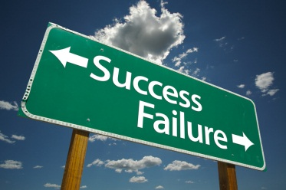
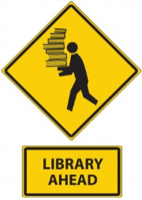
Tips for Student Success
- Know who can help you!
  - Professors teach subject content and create research assignments. Ask a professor to assist you with specific subject knowledge.
  - Librarians teach information research skills and are experts in finding information. Ask a librarian to assist you with information research skills.
- Learn to use search terms and techniques to find the best and most current information sources!
- Discover and use the library’s databases, book collections, and institutional repositories to find what you need to create a successful project or paper!
- Use effective skills to scrutinize and evaluate online information. See, search and find meaning!
- Seek diverse perspectives on your topic. Gather and ethically use information. Gain and share knowledge. Improve your grades!
Make Smart Choices, Get it Right!
I find information as I encounter it online. |  | 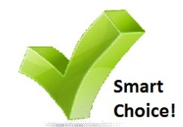  I use computer technology to scrutinize and analyze online information to find an answer.
I engage in an active effort to gather information using search terms relative to my assignments. |  | Because I regularly use the Internet, I am “alert” to information but without a formal reason to find information.
I prefer to “catch” information on Google, or another search engine, as it goes by. |  | I want to engage in an active effort to gather information using scholarly journals and professional resources.
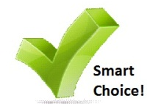  I make smart choices by learning from professors and librarians. |  | I like to do things on my own without asking for help.
Are your students asking librarians for assistance
and using library resources?
Help students make Smart Choices!
Student Success Begins @ the Library!
Five Action Steps for Librarians
- Focus with subject faculty and library colleagues on recent information behavior research that investigates today’s student approach to using digital content.
- Review the “Dow Research Team Online Graduate Students Information Seeking Model” to identify and discuss similarities and differences in students’ information seeking behaviors for class directed assignment and non-course directed topic or problem searching. Ask and answer, “What must we do to enable students to methodological find published answers, think critically and responsibly use published references and librarians’ expertise?”
- Create learning activities that provide effective electronic search guides and move student’s cognitive processes from passively browsing disorganized resources to actively searching, monitoring and scrutinizing organized library resources.
- Construct assignments that directly state measurable learning outcomes that target information literacy skills instruction and guarantee students will get feedback on their learning about appropriate and effective use of search terms, library resources and librarian expertise. Align learning outcomes for teaching information literacy skills to existing standards and objectives.
- Use multiple measurement tools to assess student learning. Collect and disseminate course level data about student learning and achievement (scores). Compare course-level assessment of student learning with library-level assessment of student learning. Do libraries make a positive difference? Use data to communicate findings and inform instruction.
Help Students Make Smart Choices
Information Literacy Course Purpose:
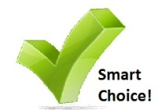
An introduction to basic strategies and skills, this course explores utilization of the library’s services, databases and collection; classification and organization of information; and evaluation and ethical use of information. Students learn how to select, evaluate, and use information.
Course Learning Outcomes:
At the end of this course, students will be able to:
- discuss the importance and changing nature of information in a modern technological society;
- describe the roles of the librarian and subject faculty in the research process;
- demonstrate use of various systems for the organization of information;
- analyze and evaluate information according to content, format, usefulness and reliability;
- select appropriate tools for accessing information and utilize search techniques to effectively retrieve information;
- organize, synthesize and repackage information into projects, presentations and papers; and
- responsibly and ethically use information.

